HD 92788

HD 92788 is a 1.08 M☉, G5 star1. Based on 57 RV HIRES measurements obtained between 2000 and 2020 and 46 RV Lick measurements obtained between 1998 and 2007, the CL survey reported a GP (HD 92788b) with a period of 332.39 ± 0.53 days, a minimum mass of 3.52 ± 0.1 MJup and an eccentricity of as well as a LPGP (HD 92788c) signal with a period of days, a minimum mass of MJup and an eccentricity of .

In the present study, in addition to the CL survey’s dataset, 80 RV CORALIE measurements obtained between 1999 and 2019 and 61 RV HARPS measurements obtained between 2004 and 2010 were used. DPASS and MCMC (1000 walkers and 500000 iterations) were used to fit the data. With DPASS and MCMC, the properties found for planets HD 92788 b and c reported in the CL survey were within the error bars associated with the values found in the present analysis. To explore the range of possible values, the semi-major axis was fixed to different values and the data fitted with DPASS. *a* up to 160 au do not significantly change the rms of the residuals (12 m/s against 11 m/s with *a* free). In this case (referred to as constrained *a*), the minimum mass is 4.2 MJup and the extremely high eccentricity is 0.95. As the RV curve of HD 92788c covers a maximum and a minimum, the stellar offset is well constrained and changing it will not change the possible solutions beyond those found with the constrained semi-major axis.

The fits are shown in Fig 1, and the corner plot in Fig 2, and the results summarized in Table 1.

Conclusion: The properties found in the CL survey for HD 92788c are not confirmed. Additional data are needed to further constrain its orbital properties.

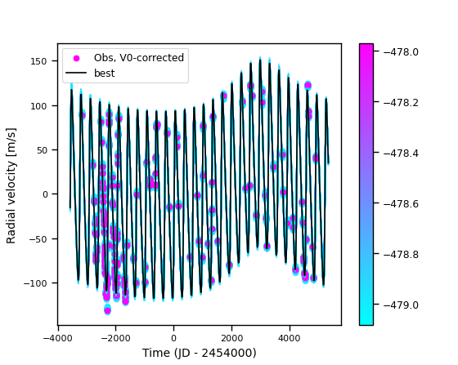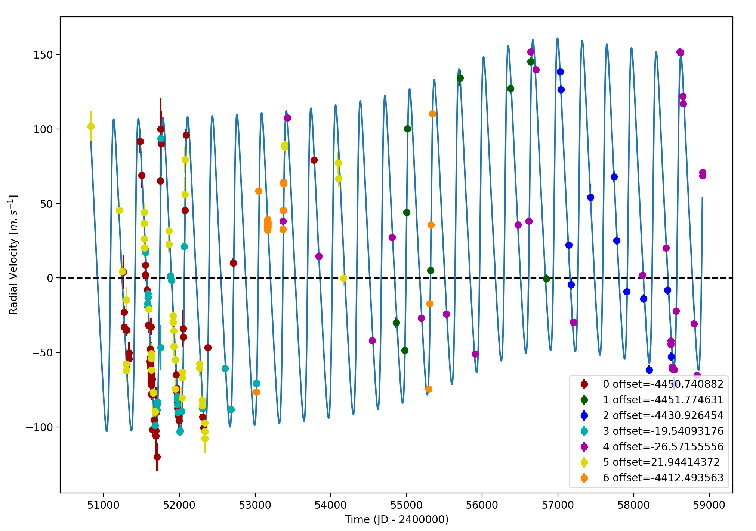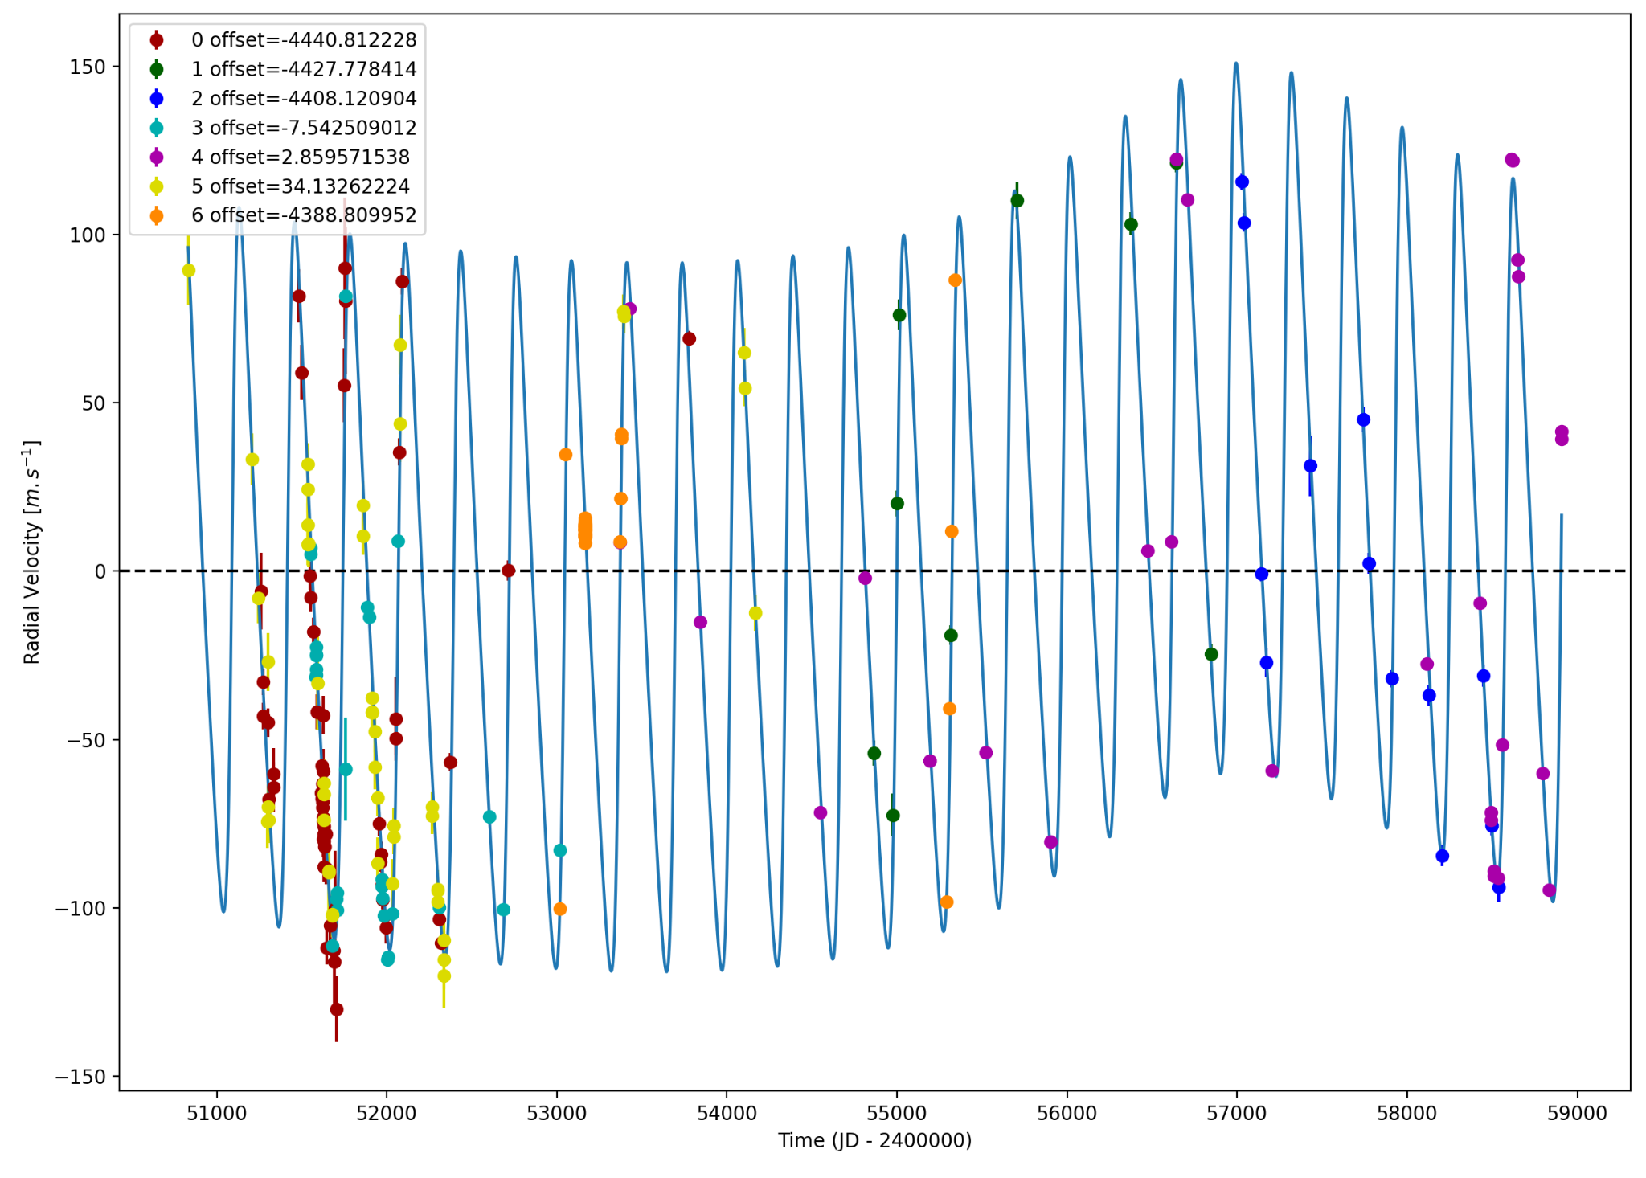

Figure 1: Left: fit of the HD 92788 RV with DPASS. Red - C98, green - C07, blue - C14, cyan - Hir94, purple - Hir04, yellow - LICK, orange - H03. The blue curve shows the best fit. Middle: fit of the HD 92788 RV with DPASS, with the minimum *a* fixed at 160 au. The points are the same as on the left. The blue curve shows the best fit. Right: fit of the HD 92788 RV using MCMC. The black curve shows the best fit. The colorbar corresponds to the log-likelihood of the fits.

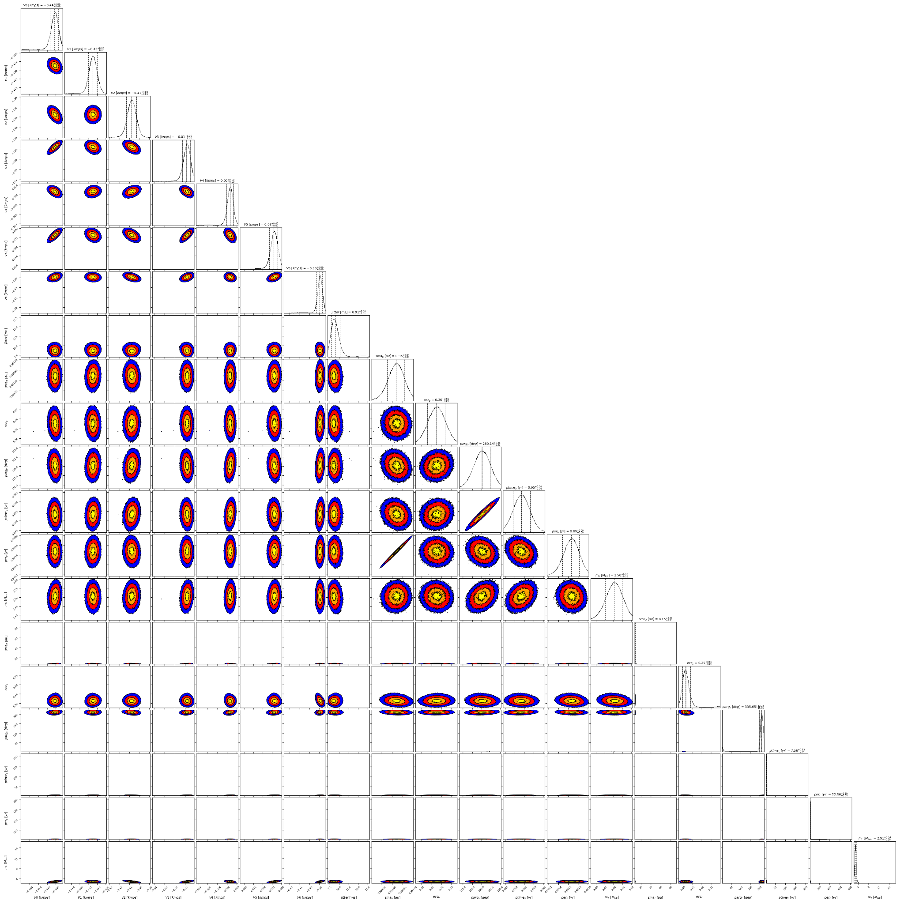

Figure 2: Corner plot of posteriors for the two-planets model MCMC fit of HD 92788 RV data.

| Parameter | Priors | | | Posteriors | | | CL survey |
| --- | --- | --- | --- | --- | --- | --- | --- |
|  | DPASS | | MCMC | DPASS | | MCMC |  |
|  | Free priors | Constrained *a* | Free priors | Free priors | Constrained *a* | Free priors |  |
| *a* (au) | b: [0,3]  c: [0,100] | b: [0,3]  c: up to 160 | b: [0.5,2]  c: [3,100] | b = 0.95  c = 8 | b = 0.95  c = 160 | b = 0.95 ± 0.01  c = | b = 0.949 ± 0.013  c = |
| Msin(i) (MJup) | b: [0,100]  c: [0,100] | b: [0,100]  c: [0,100] | b: [0,10]  c: [1,100] | b = 3.5  c = 2.9 | b = 3.5  c = 4.2 | b = 3.50 ± 0.05  c = 2.9 ± 0.3 | b = 3.52 ± 0.1  c = |
| Eccentricity | b: [0,0.95]  c: [0,0.95] | b: [0,0.95]  c: [0,0.95] | b: [0,0.95]  c: [0,0.95] | b = 0.36  c = 0.33 | b = 0.35  c = 0.95 | b = 0.36 ± 0.01  c = | b =  c = |
| Instrumentals offsets (km/s) | [-60,60] | [-60,60] | C98: [-5,-3]  C07: [-5,-3]  C14: [-5,-3]  Hir94: [-1,1]  Hir04: [-1,1]  LICK: [-1,1]  H03: [-5,-3] | C98: -4.441  C07: -4.428  C14: -4.408  Hir94: -0.008  Hir04: 0.003  LICK: 0.034  H03: -4.389 | C98: -4.451  C07: -4.452  C14: -4.431  Hir94: -0.020  Hir04: -0.027  LICK: 0.022  H03: -4.413 | C98: -4.441 ± 0.004  C07: -4.428 ± 0.004  C14: -4.408 ± 0.005  Hir94: -0.008 ± 0.004  Hir04: 0.002 ± 0.003  LICK:  H03: -4.390 ± 0.003 |  |
| Stellar jitter (m/s) | [0,40] | [0,40] | [0,30] | 7.2 | 10.9 |  |  |
| Argument of periastron (°) | b: [0,360]  c: [0,360] | b: [0,360]  c: [0,360] | b: [0,360]  c: [0,360] | b = 280  c = 341 | b = 277  c = 325 | b =  c = |  |
| Phase | b: [0,1]  c: [0,1] | b: [0,1]  c: [0,1] | b: [0,1]  c: [0,1] | b = 0.88  c = 0.1 | b = 0.88  c = 0.08 | b = 0.06 ± 0.01  c = 0.34 ± 0.04 |  |

Table 1: HD 92788. Summary of priors and posteriors obtained with DPASS and MCMC, compared to the properties reported by the CL Survey.

References

1. Rosenthal, L. et al. The California Legacy Survey. I. A Catalog of 178 Planets from Precision Radial Velocity Monitoring of 719 Nearby Stars over Three Decades. *Astrophys. J.* *Suppl. Ser.* 255, 8 (2021).